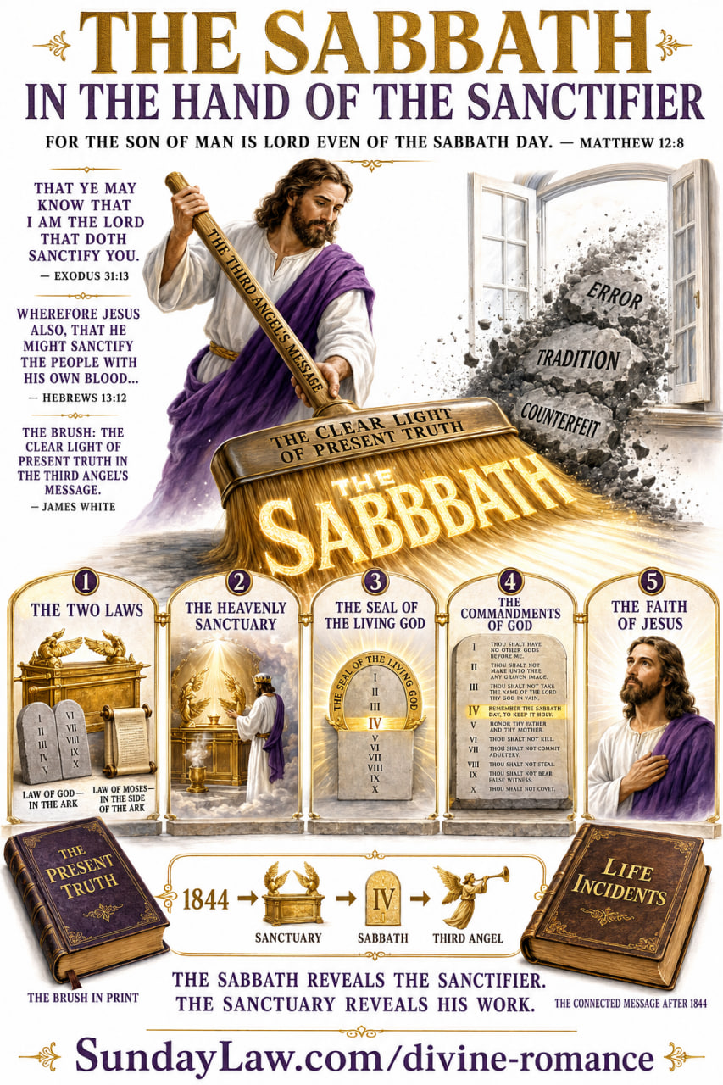
THE DIRT-BRUSH IS MOVING—AND THE ARK DOOR IS CLOSING
The Third Angel’s Message, the Second Casket, the 144,000, and the Final Invitation Into the Most Holy Place
This is more than a project to preserve old Adventist books.
It is a work of restoration—a clearing away of religious rubbish so that the immense foundation stones of the original Advent movement may again be seen, studied, and proclaimed.
When the Jews rebuilt the temple, the workmen found valuable stones among the ruins. They did not discard those stones or replace them with inferior material. They prepared them and set them again in the foundation.
In the same way, the writings, sermons, articles, tracts, books, and prophetic charts of the early Advent heralds are being recovered from decades of neglect.
We are not inventing a new message.
We are uncovering the old foundation and continuing the unfinished Reformation.
Ellen White wrote:
“The standard-bearers who have fallen in death, are to speak through the reprinting of their writings … to bear their testimony as to what constitutes truth for this time.”
— Counsels to Writers and Editors, p. 32
She also declared:
“The truths that we received in 1841, ’42, ’43, and ’44 are to be studied and proclaimed.”
— Letter 75, 1905; 15 Manuscript Releases
The pioneers are not museum pieces. Their testimony is to speak again with power.
A JOHN-THE-BAPTIST WORK FOR THE SECOND ADVENT
Ellen White made the comparison unmistakable:
“As John the Baptist heralded the first advent of Jesus and prepared the way for His coming, so William Miller and those who joined with him proclaimed the second advent of the Son of God.”
— Ellen G. White, Early Writings, p. 229.2
John the Baptist stood at the edge of a collapsing age and cried:
“Repent ye: for the kingdom of heaven is at hand.”
— Matthew 3:2, KJV
John prepared the Lord’s way by calling people away from sin, human tradition, religious pride, and empty profession. He directed them to repentance, obedience, and the approaching Messiah.
William Miller and those who joined him performed a corresponding work. They proclaimed the judgment hour, awakened the churches, called God’s people out of Babylon, and prepared a people to meet the heavenly Bridegroom.
That work must now be completed.
Those who truly join Miller’s proclamation today—studying, receiving, obeying, republishing, and repeating the connected truths entrusted to the Advent pioneers—are taking their place in the final gathering of the 144,000.
They are not merely praising yesterday’s heralds.
They are becoming heralds today.
JAMES WHITE’S EXPLANATION OF THE CASKET
In Brother Miller’s Dream, James White explained the symbols rather than leaving them to speculation.
The first casket represented:
“The great truths of the Bible, relative to the second advent of our Lord Jesus Christ, which were given Bro. Miller to publish to the world.”
The key attached to the casket represented Miller’s method of Bible study—comparing Scripture with Scripture and allowing the Bible to interpret itself.
The original casket contained a harmonious prophetic system:
- The prophetic time—1843
- The tarrying time
- The Midnight Cry in the seventh month of 1844
- The shut door
The jewels represented the children of God who received the Advent faith. They came from different churches, stations, and circumstances, but they were united by the light of the approaching Advent.
The people who scattered the jewels represented those who first rejoiced in the message but later opposed it, mocked it, denied the fulfillment of prophecy, and tore apart its connected truths.
The counterfeit coins represented false converts.
The dirt, shavings, sand, and rubbish represented the numerous errors brought among Advent believers after 1844.
The original message had been buried beneath speculation, fanaticism, false time-setting, spiritualism, human tradition, and doctrines that destroyed the harmony of the Advent faith.
Then the man with the dirt-brush entered.
James White explained:
“The man with the ‘dirt-brush’ represents the clear light of present truth, as brought to view by the third angel’s message, [Rev. xiv, 9–12,] which is now purging the errors away from the remnant.”
The dirt-brush is the clear light of present truth contained in the Third Angel’s Message.
Christ is directing the cleansing. He is purifying His people through His living Word and separating truth from error:
“Whose fan is in his hand, and he will throughly purge his floor.”
— Matthew 3:12, KJV
Jesus is cleansing His sanctuary, His message, and His people. The clear light of the Third Angel’s Message is sweeping away the rubbish that has concealed the original Advent foundation.
WHAT IS THE CLEAR LIGHT OF PRESENT TRUTH?
The Third Angel’s Message is not an isolated warning about a future mark. It is a complete and connected system of truth:
- The 2,300 prophetic days
- The judgment beginning in 1844
- The heavenly sanctuary
- Christ’s ministry in the Most Holy Place
- The ark of the testament
- The unchangeable law of God
- The distinction between the moral and ceremonial laws
- The seventh-day Sabbath
- The seal of the living God
- The commandments of God
- The faith of Jesus
- The closing work of sanctification
- The gathering and sealing of the 144,000
After the disappointment of 1844, the pioneers followed Christ by faith into the heavenly sanctuary. There they saw the ark of His testament and the unchangeable Ten Commandments.
Standing in the center of that law was the commandment Rome had attempted to bury:
“Remember the sabbath day, to keep it holy.”
— Exodus 20:8, KJV
The Sabbath was not invented by Moses, the, the Jews, or the Adventists.
Jesus created it.
Jesus rested upon it.
Jesus blessed it.
Jesus sanctified it.
Jesus commanded His people to remember it.
The Sabbath identifies Him as both Creator and Sanctifier:
“Verily my sabbaths ye shall keep: for it is a sign between me and you throughout your generations; that ye may know that I am the Lord that doth sanctify you.”
— Exodus 31:13, KJV
The Sabbath is therefore inseparably connected with the sanctuary, the law, the seal, sanctification, the Third Angel’s Message, and the faith of Jesus.
This is the dirt-brush in action: the living Word of Christ sweeping away Rome’s counterfeit Sabbath and restoring the memorial that God commanded His people to remember.
THE SECOND CASKET AND THE 144,000
James White explained the glorious second casket:
“The second ‘casket much larger and more beautiful than the former’ into which the scattered ‘jewels,’ ‘diamonds,’ and ‘coins’ were gathered, represents the broad field of living present truth into which the scattered flock will be gathered, even 144,000, having the seal of the living God.”
The second casket is not another denomination, corporation, headquarters, or human hierarchy.
It is the broad field of living present truth.
The scattered jewels are gathered into the truth as it is in Jesus. They follow the Lamb, receive His character, keep His Father’s commandments, and possess the faith of Jesus.
“And I looked, and, lo, a Lamb stood on the mount Sion, and with him an hundred forty and four thousand, having his Father’s name written in their foreheads.”
— Revelation 14:1, KJV
These are the people described at the conclusion of the Third Angel’s Message:
“Here is the patience of the saints: here are they that keep the commandments of God, and the faith of Jesus.”
— Revelation 14:12, KJV
Those who join William Miller’s proclamation today—receiving the sanctuary message, the Sabbath, the commandments of God, and the faith of Jesus—are taking their place in this final gathering.
The 144,000 give the last John-the-Baptist warning to the world:
Repent.
Come out of Babylon.
Prepare to meet the Bridegroom.
The kingdom of heaven is at hand.
“HOLD FAST”—DO NOT GO BACK
James White delivered a warning in 1847 that should thunder through every Adventist church today:
“The third angel’s message was, and still is, a WARNING to the saints to ‘hold fast,’ and not go back, and ‘receive’ THE MARKS which the virgin band got rid of, during the second angel’s cry.”
— James White, A Word to the “Little Flock”, April 21, 1847, p. 11
Hold fast.
Do not go back.
Do not retrieve doctrines from Rome’s dumpster, polish them, give them respectable theological names, and carry them back into the Advent house.
The pioneers did not borrow from Rome.
They exposed Rome.
They did not decorate papal errors.
They threw them out.
James White wrote:
“The greatest fault we can find in the Reformation is, the Reformers stopped reforming. Had they gone on, and onward, till they had left the last vestige of Papacy behind—such as natural immortality, sprinkling, the trinity, and Sunday-keeping—the church would now be free from her unscriptural errors.”
— Review and Herald, February 7, 1856, Vol. 7, No. 19, p. 149
James White named natural immortality, sprinkling, the trinity, and Sundaykeeping as vestiges of Papacy.
They were not progressive light.
They were papal rubbish left behind because the Reformers stopped reforming.
When a modern Adventist institution defends what James White identified as papal residue and condemns those who question it, Rome has simply learned to speak with an Adventist accent.
ADOPTING ROMAN HIERARCHICAL STRUCTURES
The return to Rome is not limited to doctrines. Rome also operates through a centralized religious hierarchy that places institutional authority above individual conscience and the plain Word of God.
Gospel order is biblical. Responsible organization is necessary. But gospel order is not institutional domination.
A religious organization is following Rome’s pattern when it substitutes:
- Centralized doctrinal enforcement for Bible investigation
- Institutional loyalty for loyalty to Christ
- Credential control for the unction of the Holy Spirit
- Policy manuals for the authority of Scripture
- Headquarters supremacy for individual accountability to God
- Human committees for the living direction of Christ
- Corporate reputation for truth and righteousness
The Advent movement was raised up to continue the Protestant Reformation—not to reverse it.
The fallen Protestant churches stopped reforming. They rejected the advancing light of the First and Second Angels’ Messages and clung to the traditions they had inherited from Rome.
The same tragedy is repeated whenever Adventists defend Roman doctrines, imitate Roman hierarchy, suppress Bible investigation, and place denominational authority above the living Word of God.
The Third Angel still cries:
Hold fast.
Do not go back.
Do not receive again the marks that were discarded during the Second Angel’s cry.
THE ARK DOOR IS CLOSING
In Noah’s day, the invitation of mercy did not remain open forever.
Noah preached while the ark door stood open. The people could repent, believe, and enter. But their continual rejection of light hardened their hearts.
Then the moment came:
“And the Lord shut him in.”
— Genesis 7:16, KJV
When God closed the door, no wealth, argument, religious profession, or last-minute demand could reopen it.
Christ declared that the closing days of earth would repeat the pattern of Noah’s generation:
“But as the days of Noe were, so shall also the coming of the Son of man be.”
— Matthew 24:37, KJV
The closing ark door points forward to the close of Christ’s mediatorial ministry in the heavenly sanctuary.
Jesus now ministers in the Most Holy Place. Every case is being decided. The servants of God are being sealed, and the four winds are being held while that work continues.
Ellen White wrote that Jesus would remain in the Most Holy Place “until every case was decided either for salvation or destruction.” When His intercession ends, He lays aside His priestly garments and clothes Himself “with the garments of vengeance.” Early Writings, p. 36/51
When the 144,000 are made up and sealed, Christ’s mediatorial work closes. He ceases His intercession, puts on the garments of vengeance, and the restraint upon the four winds is removed.
Then the sentence is pronounced:
“He that is unjust, let him be unjust still: and he which is filthy, let him be filthy still: and he that is righteous, let him be righteous still: and he that is holy, let him be holy still.”
— Revelation 22:11, KJV
No preacher will reopen the door.
No conference vote will reopen it.
No institutional membership will reopen it.
No deathbed promise of future obedience will reopen it.
The ark door is closing. Christ’s final work in the Most Holy Place is reaching its completion. The warning must therefore be given with the urgency of Noah standing at the entrance of the ark and John the Baptist crying in the wilderness.
THE SPIRIT AND THE BRIDE SAY, “COME”
Revelation gives the invitation:
“And the Spirit and the bride say, Come. And let him that heareth say, Come. And let him that is athirst come. And whosoever will, let him take the water of life freely.”
— Revelation 22:17, KJV
Hebrews reveals where faith follows that invitation:
“Having therefore, brethren, boldness to enter into the holiest by the blood of Jesus,
“By a new and living way, which he hath consecrated for us, through the veil, that is to say, his flesh;
“And having an high priest over the house of God;
“Let us draw near with a true heart in full assurance of faith.”
— Hebrews 10:19–22, KJV
The Spirit and the bride say:
Come into the Most Holy Place by faith.
Come through the new and living way.
Come by the blood of Jesus.
Come to your living High Priest.
Come with repentance.
Come with a true heart.
Come with full assurance of faith.
Come out of Babylon.
Come away from Rome’s traditions.
Come back to the commandments of God.
Come to the seventh-day Sabbath of the Lord.
Come to the faith of Jesus.
Come while Christ still intercedes.
Come and allow Jesus to cleanse the soul-temple, write His Father’s law in the heart, and seal His character in the life.
Come into the Most Holy Place by faith and be saved!
The pioneers are speaking again.
The foundation stones are being restored.
The dirt-brush is moving.
The rubbish is being swept away.
The jewels are being gathered.
The 144,000 are being sealed.
The way of the Lord is being prepared.
The ark door is closing.
The Spirit and the bride say:
COME!
Read the Pioneer Evidence
- Brother Miller’s Dream—with James White’s explanation
- James White’s Present Truth articles
- Life Incidents
- Ellen White’s The Great Controversy
- The Pioneer Book Library
- The Divine Romance

